Hand-Washing Smart Watch

Team #4

Jana AlHuneidi, Garth Crawford, Zheng Zhang, Gabrielle Hladik

Scrum Master: Tyler Hull

1. **Executive Summary**

In this class series, we were prompted to brainstorm ideas for designs we would want to pursue that included some form of engineering elements. Through our research and brainstorming, we used a design matrix to narrow down which project we should pursue, and what elements of that design we would want to focus on. We had decided on creating a smart watch with the capabilities of reminding the user to wash their hands, as well as how long to wash them for. With this class being online/remote, we had to work out how our team will approach this new challenge by using the resources available to us to do so to meet our end goal.

1. **Motivation**

With the prevalence of coronavirus, the Center for Disease Control and Prevention (CDC), has recommended the general public to do the following in order to curve the spread of the virus: cover one’s mouth and nose with a mask when around others, avoid close contact by keeping 6 feet apart, and to wash one’s hands with soap and water as often as possible for at least 30 seconds. As it is important to develop good hygiene habits to prevent the spread of the virus, our group posed the following question: how would someone accurately time how long they have washed their hands for? From here, we decided to create a watch that would help reinforce one of the CDC’s recommendations by notifying the user when to wash their hands and counting the time down while washing their hands while acting as a regular watch.

1. **Project Requirements**
2. Functions

We created our watch with the intent that is will perform the following functions:

1. Shall notify the user when to wash their hands,
2. Shall commence a countdown timer to time how long they will wash their hands for,
3. Shall connect/disconnect to a bluetooth-enable device
4. Shall display the time in a 24 hour format.
5. Performance

* In order to initiate the 20 seconds countdown timer, the watch shall sense the movement from the user indicating that the timer should commence via the vibration sensor. This shall be done with a forceful hand gesture by the user, usually when one shakes their hand with a certain amount of force once they are notified it is time to wash their hands.
* The watch shall remind the user to wash their hands through the means of setting alarm increments for during the day. An LED will turn on when it is time for the user to wash their hands
* The time shall be set by the user by pressing the buttons on the watch, which will display the time and date once set.

1. Requirements

While creating the prototype, we knew that it would be deemed successful if the watch was able to complete these following tasks:

* Shall sense forceful hand gesture to indicate the initiation of hand washing
* Shall count down 20 seconds for hand washing
* Shall notify the user when they need to wash their hands
* Shall display the time in a 24-hour format
* Shall be bluetooth compatible with any android device, with a downloadable application available on the android device to do so

Some other functions we wanted to potentially include if time allowed it would be:

* Shall be compact enough to be worn around the users wrist, with an enclosure designed to hold all components
* Shall be water resistant to some extent to prevent damage when user washes their hands,
* Shall display the time in a 12 hour format
* Shall collect data representing a trend of when and how often a user washes their hands, and transmit this data via bluetooth to an application on a mobile device.

|  |
| --- |
| *Figure 1 - L0 Decomposition* |

|  |
| --- |
| *Figure 2 - L1 Decomposition* |

1. **Project Planning**

Our group followed the scrum process of doing things while working on the project. To ensure that the group was in contact with one another and all work was available as needed, we used the following: created a Google Drive file to share documentation, communicated via Google Hangouts, and met in class over Zoom throughout the project. In addition to this, Trello was used to create a blueprint of the requirements of the project and what needs to be done, and outline their deadlines to guarantee all delegated work was completed in a timely manner. An outline of the deadlines we had initially set for the project can be found in figure 3A below. However as we moved forward with the project, some aspects were removed due to time constraints. [These changes](https://docs.google.com/spreadsheets/d/1_r4pPsIC6EpYZLmWQzHA1El4FqDftwgmkQchwFoAsqA/edit#gid=0) include removing some features we would have liked to include (water resistance) and changing the timeline of building the circuit, which can be found in the appendix under figure 3B.

|  |
| --- |
| *Figure 3a - Gantt chart weeks 1 - 8* |

Based on the strengths and weaknesses of each team member, tasks were assigned as follows: Jana and Zheng would program the main functions of the watch, Gabrielle would create the 3D model of the watch casing to be printed by Tyler Hull and create the notification system with bluetooth capabilities, and Garth would build the prototype. Due to time constraints, Zheng later joined Garth in building and testing the prototype of the watch, and debugging the code.

The goals of the sprints are:

* Create a prototype watch that displays time on a 12 hour clock system, as well as notify the user when it is time to wash their hands by using a buzzer for the alert.
* Create reminder function, program vibration sensor and countdown timer, program alarm and button control
* Completing and finalizing the build of the prototype, test and debug the code that will implement the watch functions and notification system. Write a final report and presentation.

1. **Prototype Description**

Our prototype is the first version of a smartwatch that has the ability to inform the user when and for how long to wash their hands throughout the day. Much was changed throughout the course of the project, reflecting the thought process behind the changes to the initial designs of the watch as well both the technical and non-technical difficulties the group encountered. At first, we believed that we would be able to include all the suggested requirements but as time moved forward, we realized that that was not the case. The original concept of the design was to have the watch be compact and wearable, as seen in figure 4 below. However, as time moved on, we realized that we would not be able to do, therefore opting to having a working prototype, rather than a compact prototype that does not work properly. The working prototype was built on a breadboard, seen in Figure 5.

|  |
| --- |
| *Figure 4 - 3D model of watch casing with components* |

|  |
| --- |
| *Figure 5 - Final prototype of watch* |

1. Components:

Our prototype consisted of the following components:

* Coin Cell Battery and Holder: this component was used as a means to power the watch to ensure that the settings set by the user will be retained when the device turns off. The coin cell battery holder was used to ensure a stable connection between the battery itself and the circuit built.
* Arduino UNO: An open-source microcontroller that can be programmed to serve the needs of the user, interacting with inputs and outputs connected to the device. Instead of using the Arduino Nano as originally intended, we used the Uno microcontroller to program the watch to allow all the components to respond to each other.
* LCD Screen: a Liquid crystal display (LCD) is used as a method to display readings continuously which changes when a voltage is applied. This was used to display the time and the countdown timer of the watch.
* HC-05 Bluetooth Module: A bluetooth serial port protocol module that communicates via serial communication which makes an easy way to interface with a controller or PC. The component was used to connect the watch to the application that was built for Android devices.
* DS 1307 RTC: A real time clock that keeps track of the current time. The RTC was used to display the time accurately once it was set by the user.
* Grove - SW 420 Vibration Sensor: This specific vibration sensor is used to detect vibrations. This was used to initiate the timer once the user is notified that it is timed for 20 seconds to wash their hands via the light emitted from the LED.
* LED (Light emitting diode): a semiconductor that emits light when conducting current. This was used to notify the user that it is time to wash their hands.
* Buzzer: The buzzer, a small audio signalling device that adds sound features to a system, was used with the LED to alert the user to when it is time to wash their hands.
* Jumper cables were used to make connections between the components.

1. User Guide

To connect the watch to the application created for the watch, which is only available on devices that operate the Android operating system:

1. Download the .apk file app on their phone.
2. Once the download is complete, open and install the file.
   1. The device may inform the user that it does not recognize the app’s developer. In this case, the user should select install anyways.
3. Once the installation is complete, open the application.
4. Connect the watch to the application:
   1. Select the scan option in the app (with the bluetooth function of the device turned on).
   2. Select the name of the device you are trying to connect to (98:D3:B1:FD:74:2E HC-05 for the smartwatch).
5. To disconnect the watch from their device, select the disconnect option.

To set up the alarm to notify the user when to wash their hands:

1. Select menu switch for alarm settings to toggle for hour and minutes.
2. Select the plus/ minus switch to enter desired hour.
3. Select the plus/ minus button to enter desired minutes.
4. Select menu to set desired time for alarm reminder.
5. LED will turn on to notify the user when it is time wash their hands.
6. Select switch to the bottom to turn off alarm.

To set up the time of the watch:

1. Select menu switch for clock settings to toggle for hour and minutes.
2. Select the plus/ minus button to enter desired hour.
3. Select the plus/ minus button to enter desired minutes.
4. Select menu to set time.
5. **Prototype Testing**

In terms of testing, the prototype’s components were tested individually in order to ensure the functionality of each feature. For the 24 hour display, we tested whether or not the user would be able to set the time and date themselves and whether this information would be displayed on the LCD screen once the user finalizes their input. This test came back as successful. We also tested the ability to set an alarm to remind the user to wash their hands along with the LCD. This test was deemed successful as we were able to set the alarm to a specific time and the buzzer rang when the alarm reached the previously specified time and displayed it on the screen. In addition to this, the LED emitted light to notify the user is it time to wash their hands as intended

The next feature that was tested was the notification and bluetooth connection to the phone application, which was somewhat of a success. Although the bluetooth capabilities of the watch successfully connected to the Android enabled device, it does not display any notifications, only displaying the option to connect or disconnect the watch (or any bluetooth-enabled device) to the phone application. The countdown timer and the vibration sensor were tested together as the countdown timer responds to the movement of the sensor. When the vibration sensor was turned, indicating that the user was washing their hands, the LED emitted light and the countdown timer initiated as expected.

Overall, the tests conducted were a success. Due to time constraints, and circumstances beyond our control, we were able to create a working prototype but not to its full potential with additional features, as originally intended.

1. **Technical Summary**

The main purpose of the watch was to allow its user to count down the time they would be washing their hands as well as when to do so, as per the recommendations of the CDC in response to the Coronavirus (Covid 19) outbreak. Rather than having the user sing a song such as “Happy Birthday” twice or thrice, we give them the option of wearing a watch, an everyday accessory, that will tell the time as well as provide these functionalities. The main features that we initially wanted to be implemented into our prototype were completed successfully, not including the compatibility. Due to time constraints, however, we were unable to include the additional features we intended to include if time permitted. Although there were some issues that arose as we moved forward with each sprint, we completed a working build of our smart watch with the ability to to remind the user when to wash their hands and time said action successfully.

1. **Teamwork Discussion**

In terms of teamwork, we did the best that we could given the circumstances. Tasks were distributed based on the skill set of each team member. Each group member contributed in the following ways to the completion of this project:

* Jana: assisted in writing the code for 12 hour clock function (operating with or without the RTC) and vibration sensor.
* Zheng: assisted in writing the code for real time clock, 24 hour clock, alarm and button control. Help debug the code, build the circuit, and test the hardware.
* Garth: build the circuit, ordered the components and assisted in programming the Arduino Nano and Uno
* Gabrielle: created the 3D model of the watch casing, created the notification system, and programmed the bluetooth module.

In addition to this, Jana and Garth rewrote the report with some assistance from Zheng for resubmission. Jana and Garth reviewed the report before resubmitting.

In terms of collaboration, all work down towards the completion of the project was added to the Google drive created to allow all members to access the content available and met over Zoom during class to discuss our progress. Although there were some issues in terms of communication and unforeseen circumstances, we were able to move forward from this and achieve our final goal: creating a working prototype of the watch. Despite not all of our goals being met in the long run, the overall project was deemed as a success as we were able to meet the main requirements we wanted to be included in the final design of the watch prototype. Had we had more time, we would have made a much more polished version.

1. **Lessons Learned**

The team learned alot about managing tasks, executing them, and debugging/testing throughout the course of the project. For instance, we originally wanted to use the Teensy 3.1 as the microcontroller that would control our watch; however, when the time came to order the components, we realized that it was discontinued from production and had to order a different microcontroller, the Arduino Nano as it had similar capabilities. This also changed while building the prototype as we realized soldering the components would be time consuming and had the same pin inputs. Therefore we used the Arduino Uno to build the prototype on a breadboard as it was more suitable for testing in such conditions. Another issue that arose was while testing the prototype. One of our team members found that the code for the vibration sensor was just for a LED module display and needed to revise the code to detect hand washing gestures. Once this was done, we were able to test the sensor and, luckily, that was a good sign for us, as we were able to see that the sensor component works. There was also an issue while programming the LCD display as it was somewhat difficult to find the sample function library to continue testing to add to our project. Once this was done, we were able to move forward with the testing phase.

What we would have done differently was improve our means of communication, schedule meetings more often, and clarify the delegation of tasks. Another thing we would have done differently is anticipating the worst case scenario so we would be prepared for such cases. We would recommend that groups take the time to set meetings outside of class, communicate with their team clearly, and assess each member’s strengths and weaknesses more thoroughly before moving forward.

1. **References**

Kiplagat (2018). “smart watch project.” Retrieved from

<https://www.academia.edu/37888349/smart_watch_project.docx>

Apple II Watch(n.d) retrieved from

<https://www.instructables.com/id/Apple-II-Watch/>**s**

DIY Hand Wash Reminder. (n.d.). Retrieved from

<https://create.arduino.cc/projecthub/Mukesh_Sankhla/diy-hand-wash-reminder-3b2ceb?ref=platform&ref_id=424_trending__beginner_&offset=28>

GodsTale, & Instructables. (2017, October 17). Make Your Own Smart Watch. Retrieved from <https://www.instructables.com/id/Make-your-own-smart-watch/>

“When and How to Wash Your Hands.” *Centers for Disease Control and Prevention*, Centers for Disease Control and Prevention, 2 Apr. 2020, [www.cdc.gov/handwashing/when-how-handwashing.html](http://www.cdc.gov/handwashing/when-how-handwashing.html)

1. **Appendix**

| https://docs.google.com/spreadsheets/d/1_r4pPsIC6EpYZLmWQzHA1El4FqDftwgmkQchwFoAsqA/edit#gid=0 |
| --- |
| *Figure 3b - updated Gantt Chart* |

| 5- most needed/effective, 1- least needed/effective/ |
| --- |
| *Figure 6 -Project Ideas Design Matrix* |

|  |
| --- |
| *Figure 7 - Bill of Materials* |

|  |
| --- |
| *Figure 8 - QR code to phone application* |

1. **3rd Sprint Review and Retrospective**

## **Previous Sprint Goal**

For the following sprint, we will be completing and finalizing the build of the prototype, debugging the code that will implement the watch functions, and test the code that will be used for said watch and notification system.

## **Sprint Backlog Status**

| **Sprint Backlog items DONE** (numbered list) | 1. *Build prototype* 2. *Write the report* 3. *Create the PowerPoint presentation* 4. *Debug code for bluetooth notification system* 5. *Decode and test code for timer, display, and vibration sensor* 6. *Test code with circuit setup and bluetooth system* |
| --- | --- |

| **Sprint Backlog items NOT DONE** | **Reason for NOT DONE** | **Keep in backlog (Y/N); why?** |
| --- | --- | --- |
| 1. *Ex.: Research Sealants* | 1. *Time constraints and scheduling conflicts that made us change our schedule/plan* | 1. *No, because we will not be able to print another case for the device* |
| *4. Compact version of watch (solder together components)* | *5. Time constraints and not being able to program the nano to our desire* | *6. No, as we will not have enough time to program the differences between the Arduino UNO and the Arduino Nano* |

## **Notable technical accomplishments**

* Building the watch circuit prototype
* Testing and debugging the code
* Having the components respond to one another as desired

## **Technical and other difficulties**

We encountered some technological difficulties. First of all, when we finished the 12-hour clock display, because we needed the real time clock to connect, we didn’t know how to complete it. The second was when we went to assemble the circuit, because there were many lines connected to the same pin, such as the VCC pin (pin provided by the power supply), so we always have the line fall off when we are soldering, and it took a long time. Finally, because of the limited time, we can only demonstrate on the breadboard. . The last is our APP notification system, the The compilation process is perfect，but always has some problems when loading.

### **(optional) Technical items that could be improved and suggested improvements**

* + A better understanding of how to piece together all the different code everyone did may have been useful and prior research on each component and how to make specific functions work would have been a good improvement to make before pursuing each task.

## **New Skills**

Team member #1: Jana - i personally feel like a majority of the learning curve came from the first two sprints. However, during this sprint, I learned a little bit about debugging and coding for the different components used. I worked on the vibration sensor so it was interesting learning how to debug betta and find other solutions to make it work.

Team member #2: Gabrielle - I learned a little bit about debugging code in MIT app inventor, but not long enough to do any major fixes, it was just a last minute adjustment after some testing. Other than that, I would say most of my learning came from the first couple sprints. This one was more focused on wrapping things up and getting ready to present the demo.

Team member #3: Zheng - I learned a lot of hardware knowledge such as the connection of circuits and the working principle of breadboards. In addition, I have a new understanding of the testing process of software and hardware. When we encounter problems in testing, we must first understand whether it is a hardware problem or a software problem, it is often necessary to test whether the hardware can work normally, and then test the software. Finally debug to solve the problem.

Team member #4: Garth - I learned the process of troubleshooting, preparing the prototype in a circuit in the initial setup and keeping track of the project via Trello. Also learned that the following components can be physically interconnected to each other using wire-wrap and printed circuit board methods. Used troubleshooting process of fault establishment, location and correction.

# **Sprint Retrospective**

For the following sprint, we decided to not work on any additional features for the watch as due to time constraints and circumstances beyond our control. With this in mind, we focused on working on finalizing the building of our watch prototype, testing the code that was created in the previous sprints to check if anything needs to be debugged or changed, and writing both the report and the presentation. Our Trello board was used to reflect these changes.

Since Garth passed along the prototype to Zheng in the previous sprint, they met up to work on the building and testing off the watch, then Zheng informed everyone of any changes needed to be made to the code as well as which components were working and which ones needed to be fixed. Jana and Gabrielle, as they awaited to hear back from Zheng, worked on the report. All group members collaborated on the final presentation.

## **Teamwork and planning - things that went well**

* Collaboration within the team
* Working together and meeting with Tyler to get help with the prototype

## **Teamwork**

* For the teamwork, Jana and Gabrielle divided the task of writing the report and creating the template of the presentation as well as its contents. Garth and Zheng worked together to finish building and testing the watch for full functionality.

## **Trello**

* Trello was used to keep track of the progress that was done for the final steps of the project as we built and tested the prototype. Some of the information provided in the ‘Journal’ card was helpful in building the final product.

## **(describe how you will utilize Trello better. One paragraph, as needed)**

* We will utilize trello better by setting deadlines to tasks while delegating them to team members that reflect where we currently are in the project by updating it consistently and adding descriptions for each task for clarification purposes.
* At the same time, we will also check trello after finishing the work, and write necessary comments and opinions on this task on it, which greatly improves our work efficiency and increases the effectiveness of communication.

## **Trello Screenshot**

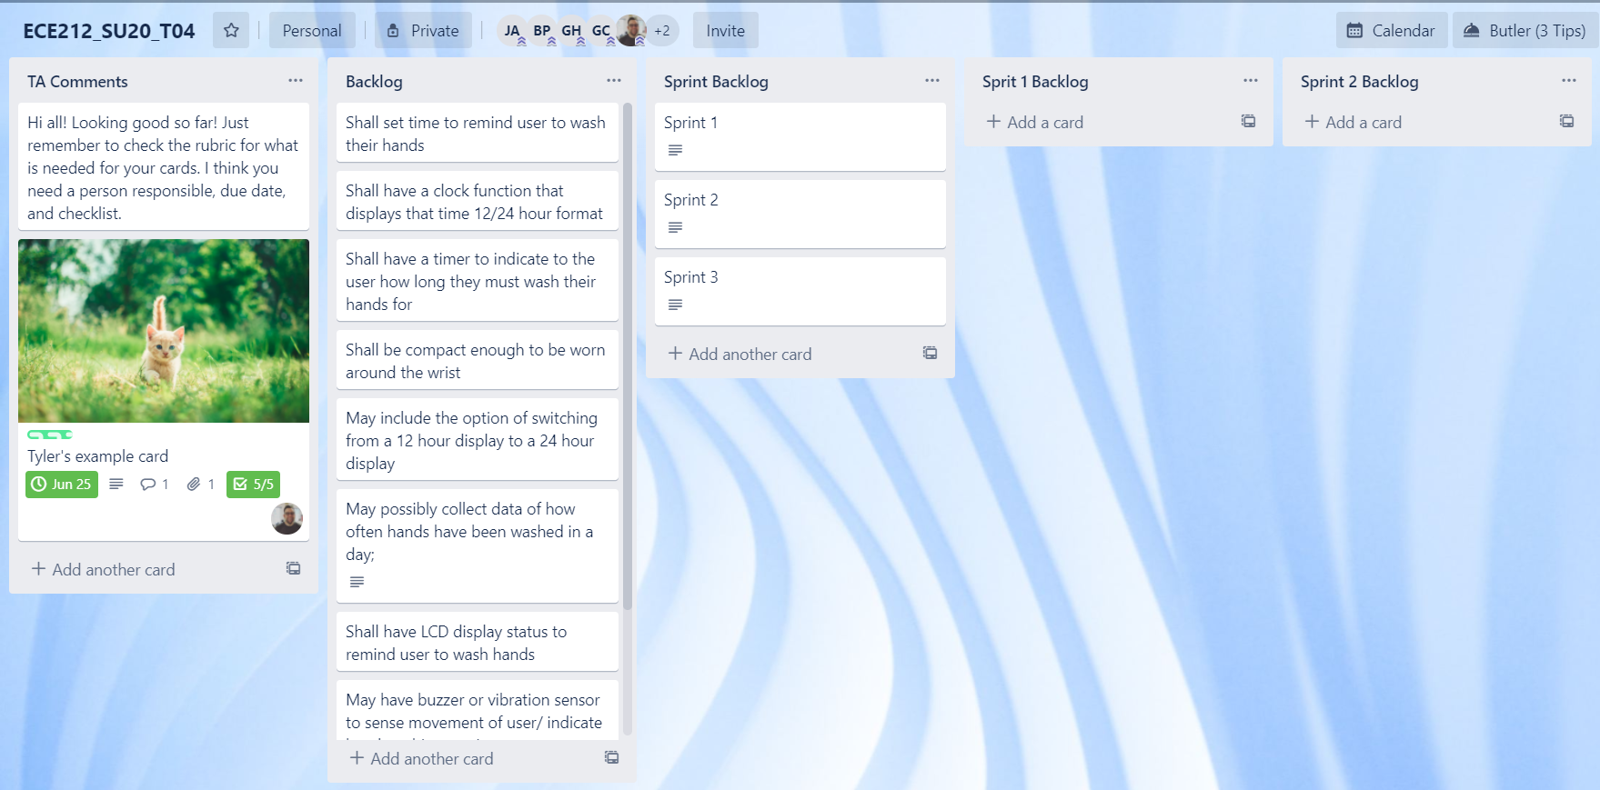

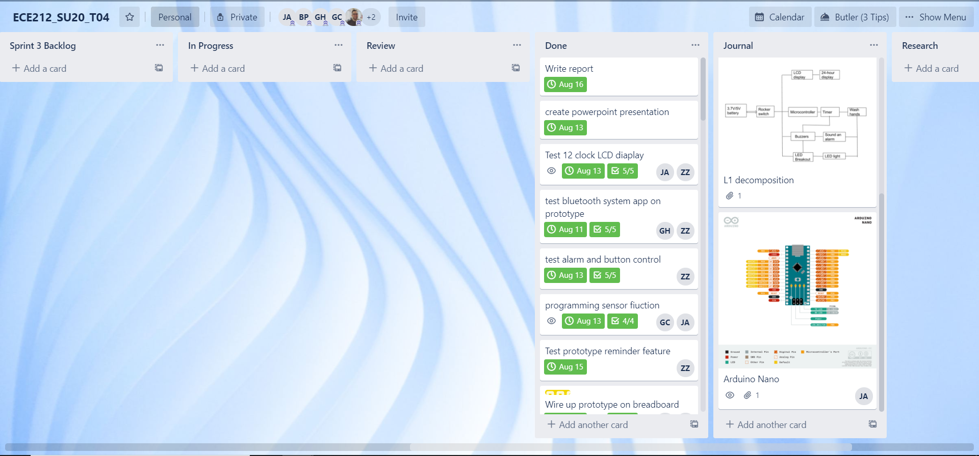

Overall, we would give ourselves a score of 3.8 (out of 5) for how well this sprint went.

Our team T04 met with our Scrum Master *Tyler Hull* on 8/11/2020. We discussed final tasks and the presentation. All team members have read this report and agree that it accurately describes our discussion.